|  |
| --- |
|  |
|  |
|  |
| **NIEM Biometrics Domain/Standards Development Plan –** |
| 24 January 2018  Version 1  OBIM |
| **Office of Biometric Identity Management** |
| Submitted by:    Integral Consulting Services, Inc  2101 Gaither Road, Suite #410  Rockville, MD 20850  Contract Number: GS00Q14OADS145  Delivery Order Number: HSHQDC-17-F-00189 |
|  |
|  |

DHS OBIM Approval

|  |  |
| --- | --- |
| Approved by: |  |
|  | Mr. John Boyd Date  NIEM Biometrics Domain Chair  Identity Technology Division  Office of Biometric Identity Management |
| Approved by: |  |
|  | Mr. Thomas Freed Date  Information Technology Specialist  Identity Technology Division  Office of Biometric Identity Management |

**Record of Changes**

| No. | Date | Reference: Page, Table, Figure, Paragraph | A = Add. M = Mod. D = Del. | Change Description |
| --- | --- | --- | --- | --- |
| 1 | 1-24-2018 | All | A | Initial version |
| 2 | 1-23-2019 | P 2,16 | M | Updated Thomas Freed Title and ESC Member names |

**Contents**

1. Executive Summary 5

2. Purpose 5

2.1 Audience 5

2.2 Period of Performance 6

2.3 Planning 6

2.4 Development Activities 7

2.5 Review Cycle 9

3. NIEM Architecture Reference 9

3.1 NIEM Framework 9

3.2 IEPD 10

3.3 NIEM Domain 12

3.4 NIEM Biometrics Domain 13

3.4.1 Biometrics Domain Organization 13

3.4.2 Leveraging NIEM for Biometrics 14

3.4.3 Biometrics Domain Content 15

3.5 NIEM-UML 15

3.5.1 UML Profile for NIEM 15

3.6 NIEM Governance and Extension 16

4. NIEM Architecture Strategies 18

4.1 Improved Service Delivery for Clients 19

4.2 A Mature Domain Model 19

5. NIEM Development Actions 19

5.1 Biometrics Domain Activities 20

6. Risks 21

7. Dependencies 22

8. Success Factors and Measurements 22

9. List of Acronyms 26

10. Additional References 26

# Executive Summary

The Office of Biometric Identity Management (OBIM) within the National Protection and Programs Directorate (NPPD) of the Department of Homeland Security (DHS), supports the DHS mission to protect our nation by providing biometric identification services to federal, state, and local government decision makers to help them accurately identify the people they encounter and determine whether those people pose a risk to the United States.

As the lead DHS entity for biometric identity management services, OBIM provides DHS and its mission partners enterprise-level biometric identity information. OBIM operates and maintains the Automated Biometric Identification System (IDENT) and provides identity services expertise as a service provider for customers across DHS, at other federal agencies, in state and local law enforcement, and globally. OBIM also focuses on improving biometric sharing in support of national security and public safety. By matching, storing, sharing, and analyzing biometric data, OBIM provides partners on the front lines of homeland security rapid, accurate, and secure identification.

This plan contains detailed information pertaining to the National Information Exchange Model (NIEM) structure and architecture for efficient information exchange. The plan also addresses how to ensure that the development of NIEM Domain content minimally disrupts OBIM architecture and maximizes the efficiency and effectiveness of OBIM plans and execution.

# Purpose

OBIM supplies the technology for collecting and storing biometric data, provides analysis, updates its watch list, and ensures the integrity of the data. OBIM has 30,000 users across federal, state, and local government agencies.

In support of interoperability, the NIEM development principles encompass the development, publication, maintenance, and application of NIEM Biometrics Domain (NBD) standardization, together with OBIM leadership in domestic and international standardization. NIEM as a tool empowers agencies to create and maintain meaningful data connections across information technology (IT) systems and the stakeholder base of federal, state, local, tribal, territorial, and international partners.

In its role as the steward of the NBD, OBIM manages all domain activities, including biometrics schema development and harmonization, data quality tiger team operations, technical analysis (biometrics data review), and community of interest (COI) outreach. This plan documents the development standards implemented at OBIM.

## 2.1 Audience

This document’s intended audience comprises all federal agencies, including NIEM Business Architecture Committee (NBAC), NIEM Technical Architecture Committee (NTAC), NIEM Executive Committee, NIEM Program Management Office (PMO), and OBIM stakeholders, including Immigration and Customs Enforcement, U.S. Customs and Border Protection, U.S. Citizenship and Immigration Services, Transportation Security Administration, Department of Justice (DOJ), Department of Defense (DOD), and Department of State. The audience also includes state, local, tribal, territorial, and Collaborative Organizations (Division/Branch) of OBIM: NPPD/Office of Internal Affairs (OIA) and DHS/OIA, DHS Science and Technology, OBIM/Customer Relations Section, OBIM/Identity Operations Division (IOD)/Systems Business Operations (SBO), OBIM/IOD/Information Sharing and Reporting, OBIM/Identify Technology Division/Service Integration Branch, OBIM/Identity Capabilities Management Division (ICMD)/Capability & Policy Coordination Branch, OBIM/ICMD Front Office, and OBIM/MD/Business and Financial Operations (BFO) Branch.

## 2.2 Period of Performance

The initial period of performance is from 29 September 2017 through 28 September 2018. If all four one-year option periods are exercised, performance ends 28 September 2022.

## 2.3 Planning

OBIM leads the biometric standards development enterprise in DHS and expands collaboration and coordination with interagency groups and international partners, while overseeing DHS-wide standards for the biometric programs and promulgating the standards across the U.S. government. NIEM planning is intended to support the development of high-quality deliverables meeting the needs of users in implementing standards, while benefiting from best-practice IT support planning.

The objectives of planning are to:

* Communicate the specific requirements of building NIEM-conformant exchanges to promote compatibility and consistent development
* Create ancillary artifacts addressing the information needs of a broad range of project stakeholders, including project sponsors, business experts, business and IT managers, and technologists
* Establish a mechanism for synthesizing the domain/business knowledge of subject matter experts
* Provide artifact reuse across projects by improving artifact consistency
* Leverage open industry standards familiar to most business analysts, architects, and other technology professionals
* Work with standards-based tools readily available in the public domain or at low cost, enabling integration projects to avoid high licensing costs and vendor lock-in
* Share valuable lessons learned and best practices from reference Information Exchange Package Documentation (IEPD) development projects

NIEM Information Exchange Packages can be developed to share information within a single domain (intra-domain exchange) or across multiple business domains (cross-domain exchange). Unless otherwise noted, the activities and tasks outlined in this plan apply to intra-domain and cross-domain modeling.

NIEM strategic planning activities include creation of documentation to support domain and/or governance activities; meetings with key stakeholders within the same domain; and the creation of artifacts in the first two planning stages of the IEPD Lifecycle (detailed in Section 3), including Scenario Planning and Analyze Requirements.

To begin exchanging information, partners need to develop data exchanges, also known as Information Exchange Packages, which are then documented as Information Exchange Package Documentation (IEPD). An IEPD is a complete definition of an IEP―a compilation of documentation that can be understood by the producer and the receiver of the information exchange. Generally, it is composed of schemas for data exchange and documentation for understanding the business context and usage. The process described for the development of IEPs and IEPDs is a guideline and is intended to be customized, as necessary. It provides a useful starting point for project planning and can help in setting high-level expectations regarding timelines, milestones, and resources.

## 2.4 Development Activities

OBIM has a role in the NIEM Standards Body and supports DHS’s focus on participation in domestic and international standardization. Its role includes:

* Coordinating and facilitating the development of standards for the NBD based on business context
* Coordinating and facilitating the development of Information Exchange Package Documentation

OBIM uses its role as the chair of the NBD and its connections with National Institute of Standards and Technology (NIST) biometric efforts to ensure alignment between NIEM and NIST. The NBD chair and the OBIM NIEM development team meet frequently (quarterly at a minimum) and participate in all NBAC meetings, reviews, and collaboration efforts across NIEM domains.

Through its stewardship of the NBD, OBIM oversees the outreach, training, data model, and protocol harmonization and provides technical assistance within the domain. Specifically, OBIM intends to advance IDENT Extensible Markup language (IXM) through implementation of the Homeland Advanced Recognition Technology (HART) system. OBIM has been unable to achieve near 24/7/365 availability because of the need to take the system offline to implement application patches, updates, and new IDENT releases. HART will be developed with a service-oriented architecture (SOA) and standards-based interfaces. The system redesign and development will address the current gaps, including those relative to capacity, security, privacy protections, interoperability, cost sustainability, performance, and availability. The system will address the gaps related to accuracy, surety of matching results, and interoperability of additional biometric identity modalities beyond fingerprints.

The NBD has been a key asset in maintaining close linkage to biometrics standards development, including 2011, 2013, and 2015 updates to the American National Standards Institute (ANSI)/NIST-Information Technology Laboratory (ITL) Biometric Standard.

**Figure 1** shows the stages of standards development, which we detail in the following paragraphs.

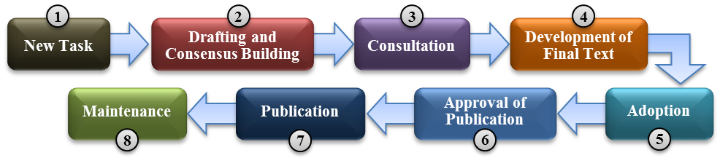

Figure 1: Stages of Standards Development

*New (or Revised) Task:* In order to revise or amend an existing document, or to develop a new Standard, it must undertake an acceptance process to ensure that the work is necessary and that the resources are in place to carry out the effort. Each member body votes on the proposal. Standards Committees vote during a meeting or via correspondence.

*Drafting and Consensus Building:* Once a task has been accepted, the core work of developing the Standard begins―often in a working group (also called a project team or maintenance team), which consists of experts nominated by Standards Committees working together to develop a draft. When the working group is satisfied that the draft is ready for wider review, it is circulated to the broader audience for comment and/or vote. During the consensus stage, a development work may go through several drafts.

*Consultation:* If the draft is approved at the Standards Committee stage, it is made available for public consultation.

*Development of Final Text:* After public consultation, the Standards Committee sends its comments to the working group, which decides whether to accept the comments (editorial, technical, or general) and modifies the draft accordingly. Once the comments have been resolved, the updated draft is circulated to Standards Committee for a vote, with a version showing the decisions made during the resolution of comments. If the draft undergoes significant technical change, it may be sent for a second consultation. If the draft passes the vote, it proceeds to the approval stage.

*Adoption:* The document is ready for adoption in its revised final version.

*Approval of Publication:* The document is submitted to the Standards Committee for approval, by vote, to publish.

*Publication:* Following formal approval, the Standard may be implemented as a Development Standard, at which point any conflicting Standards are withdrawn. Any information the committee believes will support the use of an adopted Standard may be published in the Standards Committee repository.

*Maintenance:* A Standard is reviewed periodically to ensure its currency. The review considers whether the Standard should be retained, amended, withdrawn, or revised.

From the practitioner’s perspective, the IEPD Lifecycle (detailed in Section 3) is the primary process for development of the artifacts that define an information exchange specification. The lifecycle guides the understanding of how IEPDs are ideally built and published.

Typical responsibilities of a developer are to:

* Develop the product in compliance with approved Data Standards
* Support the NIEM Biometrics Domain steward, Executive Management Committee, and other standing committees or working groups, as needed
* Assist in completion of individual or group tasks
* Work in accordance with the priorities of the program goals and tasks related to the Biometrics Domain effort
* Develop standards, a common vocabulary, and an online repository of exchange standards to support information sharing
* Follow the same technical framework of other NIEM exchange developers, to borrow from and reuse each other’s work

## 2.5 Review Cycle

The review cycle enables a broader audience to view the business context and proposed draft to ensure transparency and acceptability of the resulting standard. All external data components incorporated in the NIEM Core are subject to review and approval by the NBAC and NTAC. The NIEM Domain follows a cross-jurisdictional governance structure that reviews, edits, and provides impact assessments on changes, and promotes the use of and adherence to the following standards, specifications, and best practices:

* DHS IXM
* DOJ Federal Bureau of Investigation (FBI) Electronic Biometric Transmission Specification (EBTS) 10.0
* DOD EBTS 3.0 (4.0 under development)
* NIEM
* ANSI/NIST-ITL
* InterNational Committee for Information Technology Standards M1 Subcommittee 37

Information shared with and gained from the committees and working groups informs the Domain’s current and future operations. Whenever there is a modification, change, or addition, COI members and stakeholders participate in the review and editing, and they provide comments before release to the community and/or posting to the Domain reference websites.

# NIEM Architecture Reference

## 3.1 NIEM Framework

NIEM connects communities of people who share a need to exchange information to advance their mission, and it provides a foundation for seamless information exchange among federal, state, local, and tribal agencies. NIEM is characterized by an active user community and a technical and support framework, as shown in **Figure 2**.

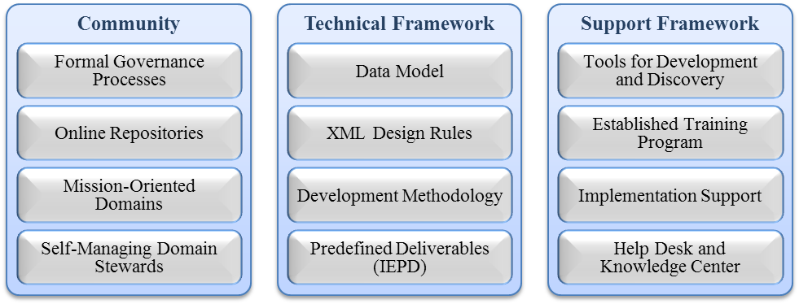

Figure 2: NIEM Framework

Reusability and standardization can be achieved using NIEM to exchange information, as shown in **Figure 3**.

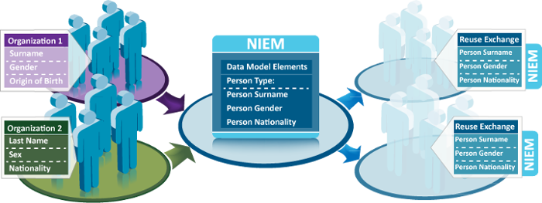

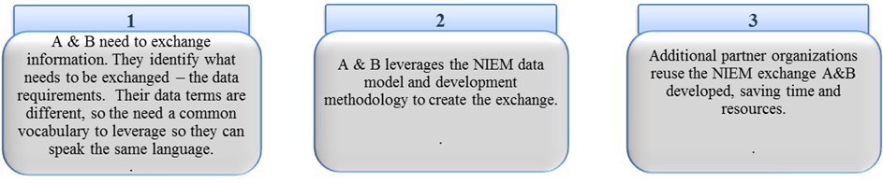

Figure 3: How NIEM Works

NIEM defines the format and structure of data in transit. Exchange partners decide how to store and process the NIEM-conformant data being exchanged.

NIEM is now in version 4.0. NIEM 4.1 Alpha is scheduled for release by the end of January 2018, NIEM 4.1 Beta is expected by the end of February 2018, and NIEM 4.1 is scheduled for release by summer 2018.

## 3.2 IEPD

A NIEM IEPD is a package that describes the construction and content of a NIEM information exchange. It contains all of the schemas necessary to represent and validate the data content of the exchange. It also contains supplemental artifacts, such as documentation, business rules, search, discovery metadata, and sample instances.

There are three core functions of IEPD development:

* To provide the business, functional, and technical details of the information exchange through predefined artifacts
* To create a core set of artifacts in a prescribed format and organizational structure to allow for consistency
* To design in order to share and reuse in the development of new information exchanges through publication in IEPD repositories

There may be one or more IEPDs for one information exchange. A NIEM-conformant IEPD must conform to the following formats:

1. NIEM Naming and Design Rules (NDR) – The NDR specifies rules to standardize schema development and provides a blueprint for NIEM conformance. It also provides rules for NIEM reference schemas, NIEM Extensible Markup Language (XML) elements, and other NIEM XML documents, including sample XML instances. NIEM, through NDR, aligns with the standards of the World Wide Web Consortium and the International Organization for Standardization.
2. IEPD Specification – Similar to any systems development lifecycle, IEPD creation has a complete lifecycle, as shown in **Figure 4**.



Figure 4: IEPD Phases

* *Scenario Planning:* Planning of the project, establishing the process, and identifying exchange business requirements
* *Analyze Requirements:* Elaboration and documentation of the business context and data requirements
* *Map and Model:* Association of local objects with types and elements in NIEM, a process called mapping and exchange content model to NIEM
* *Build and Validate:* Creation of a set of exchange-specific, NIEM-conformant XML schemas that implement the data model created for exchange
* *Assemble and Document:* Preparation and packaging of all related files for this IEPD into a single self-contained, self-documented, portable archive file
* *Publish and Implement:* Publication of IEPD for search, discovery, and reuse

IEPDs have a defined development methodology. Best practices for most organizations include many of the artifacts shown in **Figure 5**. IEPDs contain required and recommended artifacts.

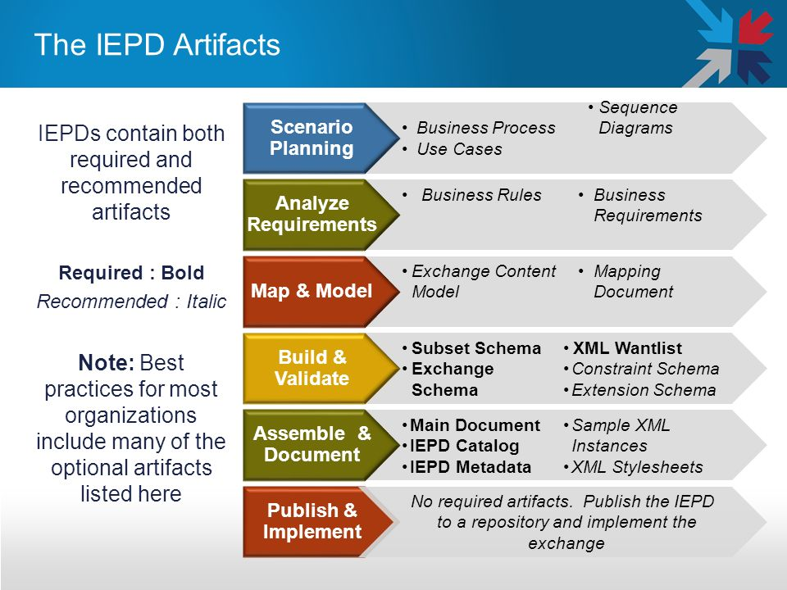

Figure 5: IEPD Artifacts

## 3.3 NIEM Domain

The NIEM Core consists of data elements that are commonly understood across all domains. NIEM Domains include mission-specific data managed through independent stewards.

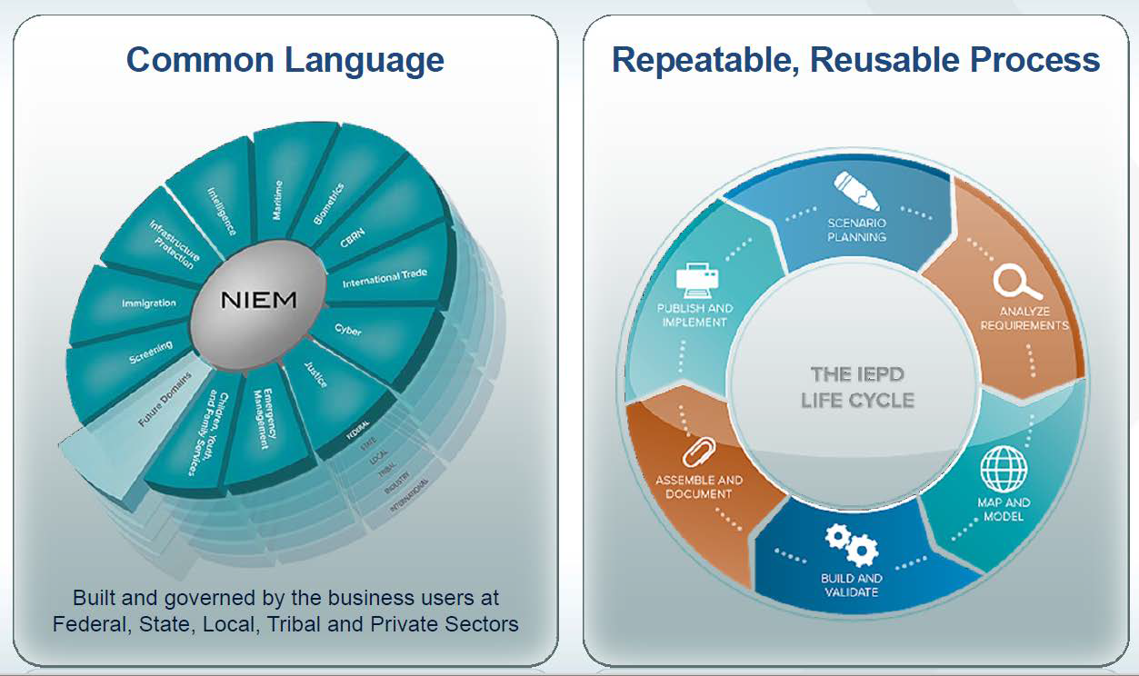

Figure 6: NIEM Domain and IEPD Lifecycle

The NIEM Common Language consists of the NIEM Core, NIEM Domains, and Future Domains and follows a repeatable, reusable IEPD lifecycle process, as shown in **Figure 6**.

## 3.4 NIEM Biometrics Domain

Operating under the stewardship of DHS OBIM, the NBD supports biometric-related services and mission-based activities, such as national defense, border management, immigration benefits, and global law enforcement, and credentialing through the joint development and alignment of XML Biometric Standards. **Figure 8** depicts the NIEM Biometrics Framework.

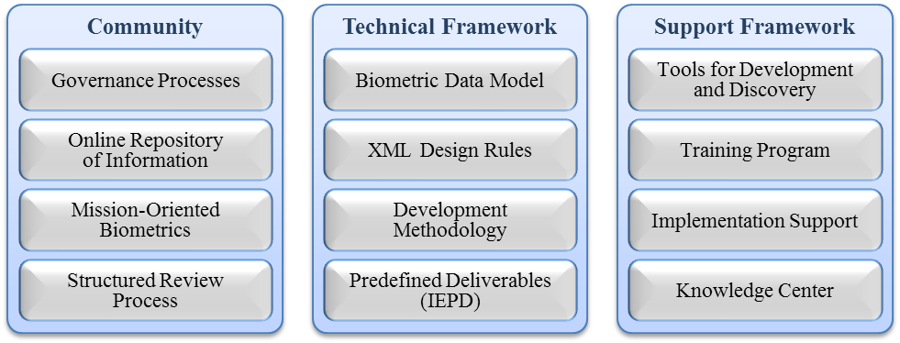

Figure 8: NIEM Biometrics Framework

The biometric domain follows a self-service model which allows for independence. Domain independence enables the domain to have the authority, autonomy, and capability to maintain its own content development and management. This ensures proactive engagement within the domain and benefits NIEM scalability while also decoupling the domain from the NIEM Core development timeline.

### 3.4.1 Biometrics Domain Organization

The Biometrics Domain is organized in alignment with domain governance as suggested by NIEM. Information concerning the Biometrics Domain, and the associated issues of domain management and standing working groups, will be communicated regularly to the NIEM PMO and NBAC to apprise stakeholders of development and activities. Such communication will be a primary responsibility of the domain steward and the Domain Executive Management Committee.

OBIM serves in the domain steward role for Biometrics. The Biometrics Domain engagement and alignment with NIEM core is shown in **Figure 9**.

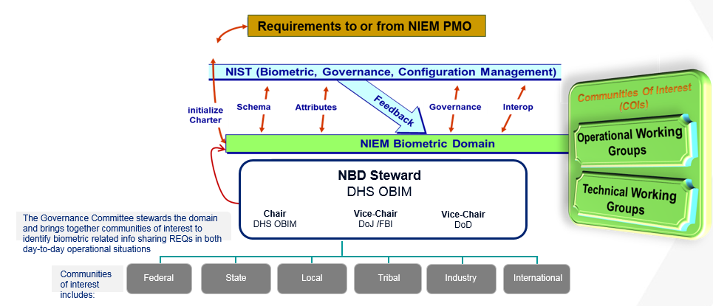

Figure 9: Biometrics Domain Organization

### 3.4.2 Leveraging NIEM for Biometrics

NIEM offers a proven approach for developing standardized, reusable information exchange packages and is being adopted across federal, state, and local government. The NIEM Biometrics Domain leverages the NIEM tools and processes that are reusable for new exchange development efforts, enabling content to be modeled in an agile and interoperable manner. Using NIEM for data exchanges allows disparate systems to speak the same language. It creates a seamless transfer of information instead of a point-to-point architecture, which is a challenge to maintain.

Further, because NIEM is based on SOA, it provides a more agile system, and implementing changes is easier and faster, avoiding cost to the government. Meanwhile, NIEM standards and IEPDs can be leveraged to help develop exchanges within the Biometrics COI. The experience and knowledge of NIEM practitioners will also help accelerate adoption.

As a primary tool, a NIEM data dictionary enables definition of terms across domains or COIs. A NIEM data dictionary contains the NIEM Core, which consists of data elements that are commonly understood across domains, and NIEM domain(s) that include mission-specific data managed through independent stewards. Leveraging NIEM provides for the establishment of a common vocabulary, forms a business and technical framework, promotes sharing and reuse, encourages data exchange standards development, enables creation of standard data structures, and improves operational efficiency and effectiveness.

The goal of NIEM conformance is for the sender and the receiver of information to share an unambiguous understanding of the information. Conformance to NIEM ensures that basic information (the NIEM components) is well understood and has a consistent meaning across communities. The result is a level of interoperability that would be unachievable with the proliferation of custom schemas and dictionaries.

### 3.4.3 Biometrics Domain Content

The NBD provides harmonized data elements for incorporation in the NBD data exchange model and will complement the NIEM Core with:

* The initial Biometrics Domain Schema identified common terms and elements within biometric schemas of major stakeholders, to build the NBD Data Model for NIEM 3.0
* NIEM 3.2 included ANSI/NIST-ITL 1-2013 updates of non-photographic imagery, forensic voice, and dental records
* NBD 3.2.1 alignment with the new DOD EBTS 4.0 and ANSI/NIST-ITL standards
* NBD 4.0 alignment with DOD EBTS 4.0 and International 4.0 releases
* The current schema inclusion of the ANSI/NIST ITL 1-2011-Update 2013/15 Standard
  1. Forensic and investigatory voice record
  2. Forensic dental and oral record
  3. Non-photographic imagery data record

## 3.5 NIEM-UML

NIEM offers two ways to develop information exchanges―through XML schema and through Unified Modeling Language (UML) tooling. NIEM also offers the ability to transform XML schema to other data formats, such as JavaScript Object Notation and Java objects.

The NIEM-UML Profile is based on the Object Management Group’s (link is external) international Model-Driven Architecture standards.

NIEM-UML provides a way for creating NIEM-conformant information exchanges in UML rather than directly coding XML schema. In addition, resources who build NIEM exchanges don’t need to worry as much about the technology details, as outlined in the NIEM Naming and Design Rules (NDR) and the Model Package Description (MPD) Specifications. These specifications and rules are already written into the profile, minimizing complexity. When implemented in a tool, NIEM-UML generates NIEM-conformant exchanges and provides a visual representation that is understandable to technical and business users alike. That visual representation of UML diagrams helps developers collaborate closely with business users to drive requirement definition and validation.

The NIEM-UML has several approaches to data exchanges:

* XML schema definition schemas
* Simple Object Access Protocol
* Web Services

### 3.5.1 UML Profile for NIEM

The NIEM-UML profile consists of four sub-profiles, as shown in **Figure 7**. Each sub-profile is a subset of UML 2.4 constructs that are extended by UML stereotypes. The subset identifies the NIEM concepts for which an analogous representation exists in UML.

Use of a subset ensures that a model produced by one user will be interpreted as expected by another user. The UML extensions define the NIEM concepts without an analogous representation in UML. All NIEM-UML models use the standard XML exchange format specified for UML 2.4 and may exchange NIEM models between conforming UML tools.

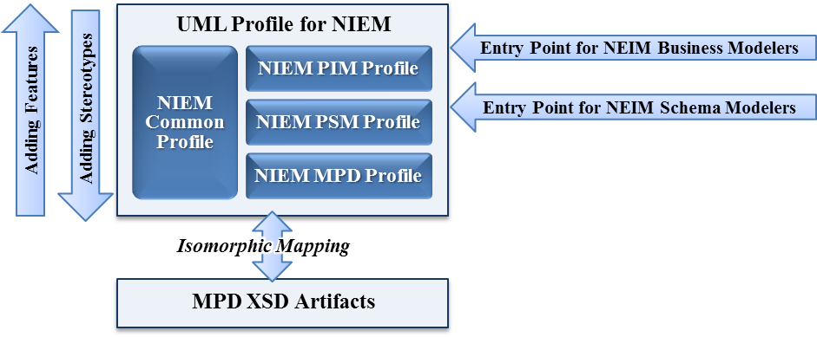

Figure 7: Components of the NIEM-UML Specification

These sub-profiles have distinct purposes and relationships:

* The NIEM Platform Independent Model (PIM) Profile provides stereotypes that enable NIEM business modelers to model an information exchange in a technology-agnostic way and to create a NIEM PIM.
* The NIEM Platform Specific Model (PSM) Profile provides stereotypes that enable NIEM technical modelers―more precisely, NIEM schema modelers―to model the technical aspect of an information exchange represented in a NIEM PSM.
* The NIEM Common Profile, leveraged by the PIM and PSM profiles, contains the core stereotypes used to represent NIEM structures in UML.
* The Model Package Description (MPD) Profile provides stereotypes for modeling NIEM MPDs, which are the final artifacts representing NIEM information exchange, based on either a PIM or a PSM model.

As indicated in **Figure 7**, the structure for the NIEM-UML profile provides direct “entry points” for NIEM modelers who are primarily business oriented and for NIEM modelers who are primarily technically oriented. It allows modelers to use a common set of profile concepts.

## 3.6 NIEM Governance and Extension

NIEM is governed by federal, state, local, tribal, and private organizations, groups, and committees that support its development, day-to-day operations, and evolution. The governance model includes:

*NIEM Executive Steering Committee (ESC):* The ESC serves as NIEM’s decision-making body regarding membership, funding requirements, program and technical direction, personnel appointments, and other organizational decisions supporting NIEM management. Domain Executive Management Committee members include the Biometrics Domain Chair (John Boyd of OBIM), two co-chairs (Jennifer Stathakis of DOJ/Federal Bureau of Investigation and William Graves of DOD) and the NIST Ombudsman (Diane Stephens).

The primary sponsors of NIEM are chief information officers of DHS, DOJ, and U.S. Health and Human Services―all members of the ESC. Advisory members and invited guests of the ESC include:

* Global Justice Information Sharing Initiative (Global)
* National Association of State Chief Information Officers
* Executive Office of the President Office of Management and Budget Federal Enterprise Architecture, through the Chief Architect
* Office of the Director of National Intelligence, through the Program Manager of the Information Sharing Environment
* Chief Information Officer of the U.S. Department of Defense
* Chief Information Officer of CrimTrac, Government of Australia

*NIEM PMO:* The NIEM PMO executes the ESC’s vision for NIEM while managing the program’s day-to-day operations, encouraging adoption and use of NIEM, and overseeing all working group and committee activities. The NIEM PMO also coordinates with COIs, principal stakeholders, and other information-sharing initiatives to promote collaboration and interest in NIEM priorities.

*NBAC:* The NBAC mission is to set the NIEM business architecture and requirements, to manage the NIEM Core, and to facilitate the processes for the regulation and support of NIEM domains.

The NBAC focuses on the following areas:

* Business Architecture―The NBAC oversees and validates the construction, maintenance, and use of the business architecture framework for NIEM.
* NIEM Core―The NBAC provides management and oversight of the NIEM Core, the central part of the NIEM data model that’s commonly understood across all domains.
* Community―The NBAC serves as the forum for the admission of new domains and interactions between domains, and coordinates action to maintain the NIEM community.

The committee’s specific responsibilities are to:

* Maintain the integrity, usability, and maturity of the NIEM Core, and engage in any requisite harmonization and issue resolution activities
* Determine the need for new data model releases, as necessary, such as to accommodate new domains and content, or to provide business requirements to the NTAC
* Submit recommendations to the ESC concerning the admission of a new domain into the NIEM data model

The NBAC comprises stakeholders of diverse communities. NIEM’s domains, communities established to manage and govern a portion of the NIEM data model, form the foundation of the committee. The NBAC is led by co-chairs and includes voting members, a NIEM PMO liaison, observers, and invited participants.

*NTAC:* The primary mission of the NTAC is to define and support the technical architecture that governs NIEM. In addition, the NTAC:

* Documents and maintains NIEM’s technical specifications
* Provides robust, effective development of the NIEM Core structure and complementary processes supporting and enabling users to efficiently develop, use, and reuse NIEM-conformant model package description components
* Delivers and maintains a tool strategy that meets stakeholder requirements in support of information exchange across organizations

The committee’s specific responsibilities are to:

* Establish and support the NIEM technical architecture
* Establish mechanisms and processes for publishing NIEM content artifacts
* Ensure that all content in the NIEM data model conforms to NIEM specifications
* Maintain communication and interaction with other NIEM program entities, such as the help desk, NBAC, and PMO
* Analyze and assess emerging technologies and how they relate to NIEM, and develop a roadmap for future capabilities
* Establish goals, milestones, and desired outcomes, and measure performance

NTAC members represent operational practitioners and subject matter experts, key stakeholder agencies, domains, and systems developers throughout the levels and branches of government, as well as solution providers. Membership types include co-chairs, voting members, PMO liaison, lead developers, and observers/invited participants.

**Figure 8** presents the NIEM governance structure.

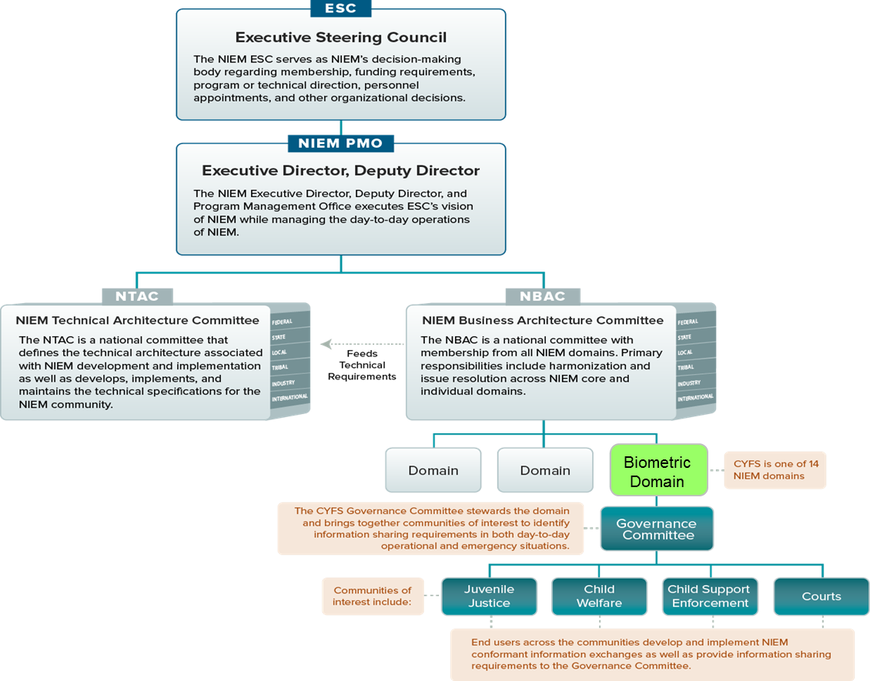

Figure 8: NIEM Governance Structure

# NIEM Architecture Strategies

**Table 1** summarizes the major goals and objectives of the NIEM implementation.

***Table 1: NIEM Implementation Goals and Objectives***

| Goal/Objective | Desired Outcome | Measurement | Impact |
| --- | --- | --- | --- |
| Standardization | Enterprise-wide standards | Adopted by inter-/intra- agencies and programs | Improved efficiency |
| Reusability | Shared and reused data | Adopted as a model by other states | Reduced development time |
| Reduced data redundancy | Less data redundancy | Adopted by inter-/intra- agencies and programs | Improved data integrity and reduced errors |
| Governance | Policies and procedures | Adopted by inter-/intra- agencies and programs | Conformance to standards |
| Conformance to NIEM framework | Standardization | Adopted by inter-/intra- agencies and programs | Conformance to standards, reusable services |
| Improved cost | Streamlined services to reduce cost | Adopted by inter-/intra- agencies and programs | Low cost, reduced errors, and reusable services |

## 4.1 Improved Service Delivery for Clients

Client service delivery is improved with the updated Biometrics Domain schema, better aligning to modifications and corrections within the Standard, providing for updates, and setting the stage for harmonization efforts between major stakeholders in NIEM 4.0 (updates to DOD EBTS/DHS IXM).

As Biometrics Domain steward, OBIM enjoys important benefits with respect to client service delivery:

* + Managed Data Model harmonization and the ability to rapidly update and adjust to changes in partner/stakeholder messaging protocols (IXM vs. DOD EBTS vs. DOJ EBTS)
  + Direct engagement with all COI members of the Biometrics Domain (federal, state, and local organizations)
  + First stop for international partners approaching NIEM for information exchange tools and best practices for identity management
  + Close working relationship with all standards organizations

## 4.2 A Mature Domain Model

As NIEM achieves sustained growth, OBIM will continue to support best practices while improving foundational characteristics through innovation. The NIEM Biometrics Domain was launched in 2012 in tandem with the NIEM 3.0 release. The Biometrics Domain has benefited from strong NBD executive leadership and has been a major NIEM contributor. The Biometrics Domain received the Best of NIEM Honorable award in 2012. The NIEM 3.2 schema was updated in 2015 with new modalities in alignment with ANSI/NIST-ITL standards. NIEM 4.2 is under development with a focus on International outreach and alignment.

# NIEM Development Actions

NIEM has had a major impact in the public sector and is beginning to gain traction in other arenas, including state, local, and international entities. NIEM has the opportunity to extend its resources, platforms, communities, and technical prowess to a much broader audience, reducing barriers to information exchange and unleashing the potential of rapidly advancing technology.

Essential elements to NIEM planning and associated activities include:

* Program Maturation – Program maturation makes possible solidified policies, processes, platforms, tools, and community engagement practices, and creates the opportunity to refine, streamline, and broaden (when warranted) outreach and capabilities. As NIEM moves toward such maturity, new domains that closely reflect the real‐world business and operational landscape are expected to emerge and to absorb the content of the initial domains via one or more of the domain interaction methods.
* Program Expansion and Evolution – DHS OBIM will replace its identity management system, IDENT, with HART, an enhanced, scalable, modular, multimodal identity management system. HART system design will provide for the expansion of interoperable services similar to those provided to FBI and DOD systems, including additional federal agency biometric systems and non-federal customers, without requiring modifications to its foundational system architecture. HART Increments 1 and 2 will support IXM 6.0.4, 6.0.7, 6.0.8, and 6.0.9, which are backward-compatible with each other. IXM 6.0.x data elements are based on NIEM attributes. IXM 6.0.9 is approximately 10-12% conformant to NIEM and as the Agile development proceeds, it will be made as NIEM conformant as possible. Future versions of IXM should continue to be based on NIEM constructs, as applicable.

The NIEM vision is to evolve the program through improved integration across technologies with a more simplified user experience. Some of the priority areas include:

* + Utilization of JSON in addition to XML.
  + Simplification of NIEM to lower the barrier of entry for NIEM users and improve the technical resources available for implementers.
  + Increasing reach of customer engagement.
  + Improving brand awareness through documentation of NIEM success stories.
  + Advancement of the integration with the international community including additions to NIEM Core in version 4.0.

The NIEM Data Model maturity is achieved through continuous development and refinement of IEPDs, prompting identification of new data components, refinement of existing data components, and identification of candidates for harmonization. The NBAC and NTAC provide technical assistance to guide organizations through the IEPD process and recommend strategies for partnering on similar efforts. NIEM 4.0 (and beyond) provides ample opportunity to make core and domain data models more useful. The Domain also supports tigers teams comprised of members of the community of interest to address specific issues in support of either working group or the domain at large.

## 5.1 Biometrics Domain Activities

There are a variety of activities surrounding the Biometrics Domain which include maintenance and operation of the domain, operational support, data dictionary updates, and harmonization and reconciliation. Some of the specific tasks and activities include:

* + Participation in all required NIEM Activities which include the monthly NBAC meeting, NIEM Face2Face and Tiger Teams, as well as community outreach, NBAC technical review and mentorship activities
  + Ongoing outreach through the NIEM Facilitator to support major releases and events
  + NBD Executive Management support for the Global Identity Summit
  + Support of the NIEM 4.1 incremental release which is under development and has primary planned updates to modified ITL 2015 schema as put forth by ITL XML Working Group
  + Internal OBIM IXM Review and Alignment
  + Support DoD EBTS development team with ongoing NIEM alignment analysis
  + Participation in ANSI/NIST-ITL Working Group to refine ITL (2015) schema with major stakeholder requirements
  + Technical assistance relating to request by Information Sharing and Services Office (IS2O)
  + Monitoring of the NIEM Biometrics Facilitator account.
  + Internal OBIM IXM review and alignment including IXM 6.0.9 Agile support with updates to the existing NIEM IXM / XML data dictionary spreadsheet as required, and identification of elements for possible inclusion in NIEM for 4.1
  + NIST Biometrics standards evolution
  + Biometrics Domain support of the XML working group, with continued refinement of ANSI/NIST-ITL standards and collaboration with the 2017 ITL XML Working Group
  + NBD schema enhancement
  + Resolution and tracking of NIEM technical issues using issues tools provided by NIEM PMO and NIEM help desk
  + Provision of a common data dictionary of elements to be included in NIEM, spanning federal, state, local, tribal, private, and international boundaries represented by the COI
  + Support of domain reconciliation and cross-domain harmonization, resulting in future NIEM releases (major and minor), as needed
  + Understanding and incorporation of related external data standardization initiatives, as appropriate
  + Ongoing identification of data requirements based on exchange/data modeling and development efforts

# Risks

The risk mitigation step involves development of mitigation plans designed to manage, eliminate, and /or reduce risk to an acceptable level.

The risk mitigation would involve following steps:

1. Development of mitigation plans designed to manage, eliminate, or reduce risk to an acceptable level.

2. Implement risk mitigation plan

3. Continually monitor and assess its efficacy

4. Review and suggest actions, to revise or change the course-of-action as needed

5. Periodically revisit the basic assumptions and premises of the risks

6. Scan the environment to see whether the situation has changed in any way that affects the nature or impact of the risk

7. Identify the new risks as project evolves

The risks and corresponding mitigations associated with Biometrics Domain development are as follows:

| Risk | Mitigation |
| --- | --- |
| Maintaining real-time harmonization via incremental releases of biometric schema during a period within which several major stakeholders are updating internal messaging platforms | Continued participation of identity management COI ensures harmonization across systems in existence and under development. |
| Continuing implementation and usage of biometrics beyond the public sector shows need for engagement extending past traditional NIEM audiences for emerging data exchange scenarios | Program maturation leads to solidified policies, processes, platforms, tools, and community engagement practices, and provides the opportunity to refine, streamline, and broaden (where warranted) outreach and capabilities. As NIEM moves toward program maturity, new domains beyond the public sector are expected to emerge and to absorb the content of the initial domains via one or more of the domain interaction methods. |
| Identification of issues late in the project delivery lifecycle | Using an Agile development approach facilitates continuous involvement from the stakeholders, reducing the likelihood of misunderstandings. Additionally, because of frequent delivery and inspection, problems will be detected early in the project. |
| Legal compliance concerns | The primary sources of legal compliance risk―contracts, regulations, and litigations―can be mitigated by communicating the results to and seeking advice from the broader enterprise. |
| Funding issues | To secure full funding, sponsors must have confidence that the project will deliver and that the benefits of adopting NIEM are worth the investment. Sponsor input should be continually incorporated in the architecture strategy, and emphasis should be placed on upfront long-term commitments to increase the likelihood of full funding. If funding gaps appear, opportunities for fundraising from traditional and non-traditional sponsors and other sources should be explored. |
| Governmental changes including compliance requirements | Continual evaluation of processes and lifecycle in accordance with new policies and compliance requirements following the risk mitigation steps. |

# Dependencies

Maturity of the Biometrics Domain depends on the following factors:

* + Sufficient access; timely and actionable information
  + Adequate data to decide what information to share with whom
  + Ability to obtain and share data in readily consumable formats
  + Collection of complete and accurate data in support of the mission

# Success Factors and Measurements

OBIM collaborates within DHS, with other federal agencies, and with the private sector and academia to conduct research, establish standards, prioritize identity services in DHS, and advance the science of biometric identification. Homeland Security Presidential Directive 12 (HSPD-12), HSPD-5, and National Security Presidential Memorandum 7 require interoperability among all agencies and participation in ongoing biometrics development, test, and evaluation.

Performance measures are required to fulfill the responsibilities of OBIM and DHS under the Government Performance and Results Act, P.L. 103-62, and applicants who receive funding under this effort must provide data that measure the results of their work.

Performance measures for developing, testing, or evaluating enhanced biometric tools or technologies for DHS applications are as follows.

| Objective | Performance Measure(s) | Data Grantee Provides |
| --- | --- | --- |
| NIEM conformance | 1. Facilitation of NIEM standards during successful development, maintenance, and testing of Biometrics Domain as related to IXM and the IXM schema 2. Ensure that NDR specified rules and standardized schemas are developed, providing the blueprint for NIEM conformance 3. Ensure that OBIM systems and applications are prepared to respond to data messaging or data interoperability standards developed for the Domain 4. Ensure that NIEM is accessible and understandable to all stakeholders 5. Ensure that it is transparent for all decision-making authorities 6. Ensure that it operates efficiently 7. Ensure that it maintains conceptual integrity | 1. A final NIEM conformance report indicating what part of Biometrics Domain, as related to IXM and the IXM schema, is NIEM compliant 2. Final report indicating number of rules specified and number of NIEM-conformant schemas developed 3. Number (percentage) of applications prepared to respond to data messaging or data interoperability standards developed for the Domain 4. Available and accessible to all stakeholders 5. Transparent for all decision-making authorities 6. Able to operate as specified 7. Able to provide conceptual integrity |
| Semantic integrity of NIEM information exchange standards | 1. Ensure that exchange standards are reflected in the model in a coherent and consistent manner 2. Ensure that governance constructs are consistent with and documented in a complete and actionable manner | 1. Results of data content reflect allowable values 2. Invalid data entered results in error; maintain data integrity |
| Clarity and consistency | 1. Make sure that information presented is reasonable, understandable, measurable, and obtainable 2. Ensure consistency with basic program | 1. Remove any ambiguity or unclear or duplicate information 2. Complies with legislative and other programs defined by agency |
| Compliance | 1. Ensure compliance with DHS program development rules and regulations or legislative requirements | 1. Provide report of compliance |

NIEM embodies attributes and values ensuring successful operational use and relevance:

* + *Accessibility:* NIEM is practitioner based. It is designed to address operational requirements for information sharing among practitioners at all levels of and across the branches of government. Practitioners are encouraged to participate in NIEM in a variety of ways. The governance and operations of the NIEM program are transparent and responsive. Additionally, NIEM must be accessible and understandable to stakeholders, given reasonable investment of time and energy. NIEM is based on well-established principles that reflect transparent decision making, effective operations, and conceptual integrity, providing a framework for broad understanding of the program.
  + *Semantic Integrity:* NIEM information exchange standards are reflected in the model in a coherent and consistent manner, use the model and governance constructs in a consistent manner, and are documented in a complete and actionable manner. The result is a model that ensures semantic integrity by guaranteeing that data content reflects allowable values.
  + *Low Total Cost of Ownership:* Consistent use of NIEM delivers measurable cost savings (initially and ongoing) as a consequence of a) using standardized analysis, development, and implementation methodologies; b) effectively reusing common data exchange specifications and data components; and c) leveraging the economy-of-scale savings realized by shared governance, training, technical assistance, engineering, and outreach resources.
  + *Scalability:* NIEM processes, tools, and information exchange standards are scalable, and apply to information sharing with equal force regardless of the breadth or scope of information sharing contemplated and irrespective of the level, unit, or branch of government.

Assessing NIEM’s operational performance, strategic value, business benefits realization, and return on investment is a fundamental activity across the NIEM program. As part of a comprehensive performance management program, key performance indicators associated with the NIEM program will be thoughtfully developed, consistently monitored, and regularly reported to ensure effective outcomes, efficient operations, and appropriate value for the investment.

Example performance measures include:

* + Number of federal agency signatories to the NIEM Memorandum of Understanding
  + Number of relevant domains, COIs, and stakeholders actively engaged in developing, using, and/or reusing NIEM-conformant information exchange package documentation and universal and common core components
  + Measures of community awareness, engagement, support, adoption, and use of the NIEM program, including surveys demonstrating NIEM awareness, understanding, and support
  + Metrics associated with NIEM website page views, including characteristics of website use (e.g., number of page views, duration of visit, navigation during visit, documents and models downloaded)
  + Number of NIEM training programs conducted, number of persons trained, and assessments of the quality and operational relevance of the training provided
  + Metrics associated with instances of technical assistance provided, help desk calls resolved, NIEM-related conference presentations made, and assessments of the quality of assistance and presentations
  + Number of NIEM universal and common core components registered, and measures associated with the stability of these components
  + Number of components harmonized
  + Number of NIEM-conformant IEPDs registered
  + Number of domain components registered
  + The nature, volume, and business value associated with reuse of NIEM universal and common core components and IEPDs
  + The extent of use and implementation of NIEM universal and common core components and NIEM-conformant IEPDs among key domains (i.e., those addressing strategic national priorities)
  + Cost savings achieved by using NIEM universal and common core components and NIEM-conformant IEPDs among users/participants at all levels of government
  + Improvement in the number, timeliness, and effectiveness of exchanges operationally achieved using NIEM universal and common core components and NIEM-conformant IEPDs
  + The number of information systems actively sharing information using NIEM universal and common core components and NIEM-conformant IEPDs, leading to improved quality of decision making

# List of Acronyms

BFO OBIM Business and Financial Operations Branch

DOD Department of Defense

DHS Department of Homeland Security

DOJ Department of Justice

EBTS Electronic Biometric Transmission Specification

FBI Federal Bureau of Investigation

HART Homeland Advanced Recognition Technology

ICMD Identity Capabilities Management Division

IDENT Automated Biometric Identification System

IOD Identity Operations Division

ITL Information Technology Laboratory

IXM IDENT Extensible Markup Specification

NBAC NIEM Business Architecture Committee

NBD NIEM Biometrics Domain

NIEM National Information Exchange Model

NIST National Institute of Standards and Technology

NPPD National Protection and Programs Directorate

NTAC NIEM Technical Architecture Committee

OIA Office of Internal Affairs

SBO Systems Business Operations

# Additional References

* + Biometrics Domain Charter
  + NIEM normative and non-normative documents and other resources (https://reference.niem.gov/niem/)
  + BSI Pocket Guide to Standards Development (https://www.bsigroup.com/Documents/about-bsi/NSB/BSI-pocket-guide-to-standards-development-UK-EN.pdf)